|  |  |  |
| --- | --- | --- |
|  | | |
|  | F:\Download\SeafileDownload\Seafile\最近修改的文件\8266系列规格书\图片资源\公司图标.pngF:\Download\SeafileDownload\Seafile\最近修改的文件\8266系列规格书\图片资源\公司图标.pngF:\Download\SeafileDownload\Seafile\最近修改的文件\8266系列规格书\图片资源\公司图标.png | |
|  | |
| Rd-03D_V2 Specification | | |
| Version | | V1.0.0 |
| Copyright | | ©2025 |

**Document resume**

|  |  |  |  |  |
| --- | --- | --- | --- | --- |
| **Version** | **Date** | **Develop/revise content** | **Edition** | **Approve** |
| V1.0.0 | 2025.04.01 | First Edition | Yuan Nan Nan | Guan Ning |
|  |  |  |  |  |
|  |  |  |  |  |
|  |  |  |  |  |
|  |  |  |  |  |
|  |  |  |  |  |
|  |  |  |  |  |
|  |  |  |  |  |
|  |  |  |  |  |
|  |  |  |  |  |
|  |  |  |  |  |
|  |  |  |  |  |
|  |  |  |  |  |
|  |  |  |  |  |
|  |  |  |  |  |
|  |  |  |  |  |
|  |  |  |  |  |
|  |  |  |  |  |
|  |  |  |  |  |
|  |  |  |  |  |
|  |  |  |  |  |
|  |  |  |  |  |

目录**Content**

**Content**

1. Product overview 4

1.1. Characteristic 5

2. Main parameter 6

2.1. Electrostatic requirements 6

2.2. Electrical character 6

2.3. Radar sensing distance 7

2.4. Power consumption 7

3. Appearance size 8

4. Pin definition 9

5. Schematic diagram 10

6. Design guidance 10

6.1. Application of guidance circuit 10

7. Precautions for radar installation 11

7.1. Installation environment requirements 11

7.2. Installation method and sensing range 12

7.3. Power supply 13

7.4. GPIO 14

8. Storage condition 14

9. Reflow welding curve 15

10. Product packaging information 16

11. Contact us 16

Disclaimer and copyright notice 17

Notice 17

Important statement 18

# Product overview

Rd-03D_V2 version is a radar module developed by Shenzhen Ai-Thinker Technology Co., LTD., which includes extremely simplified 24 GHz radar sensor hardware and intelligent algorithm firmware. The hardware of the module consists of AIoT millimeter-wave radar chip ICL1122, high-performance one-shot two-receiver microband antenna, MCU and peripheral auxiliary circuit. The intelligent algorithm firmware uses the proprietary advanced signal processing technology of FMCW waveform and ICL1122 chip.

Rd-03D_V2 version of the module can accurately perceive the movement state of the human body and the region. The intelligent algorithm can realize the identification and tracking of the movement track, and can detect multiple targets in the designated area and report the results in real time. To realize the speed measurement and ranging of the target in the region, with faster identification speed and lower power consumption.

Based on this design, users can quickly develop the corresponding target positioning tracking products. This scheme is mainly applied in ordinary indoor scenes, such as home, office and hotel, to realize the positioning and tracking of single or multiple human bodies. The module can be quickly configured, suitable for all kinds of public publicity facilities, intelligently distinguish the human body in the movement, micro and static form, control the equipment switch. The module has good resistance to external interference and is not affected by wireless signals such as WIFI.

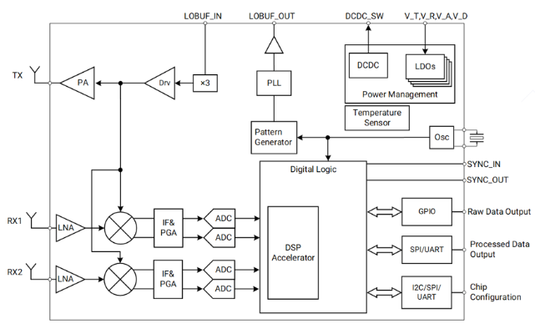Figure 1 ICL1122 chip architecture diagram

## Characteristic

* Use standard 1*4P-1.25mm socket interface
* The radar supports the 24GHz ISM frequency band
* High-performance two-receiver microband antenna
* Accurate target positioning and tracking
* The farthest induction distance is 8m
* The range azimuth ± 60 and pitch ± 30
* Support wall installation
* Provide visualization tools to support the configuration of tracking detection range, data reporting interval, and target retention time
* Ultra-small module size: 15 * 44mm
* Automatically load the default configuration, plug and play
* Support UART, you can realize the intelligent reference adjustment of radar through the serial port, convenient and fast
* 5V single power supply
* Typical application scenarios:
* Smart home
* Intelligent business
* Bathroom
* Smart lighting

# Main parameter

Table 1 Description of the main parameters

|  |  |
| --- | --- |
| **Model** | Rd-03D_V2 |
| **Package** | Standard 1*4P-1.25mm socket interface |
| **Size** | 15.0*44.0(±0.2)mm |
| **Antenna type** | On-board antenna |
| **Frequency range** | 24G ~24.25GHz |
| **Working temperature** | -40℃ ~ 85℃ |
| **Storage environment** | -40℃ ~ 125℃, < 90%RH |
| **Power supply range** | Power supply voltage 5V, power supply current ≥200mA |
| **Support interface** | UART |
| **Serial port rate** | Default 256000 bps |

## Electrostatic requirements

Rd-03D_V2 is electrostatic sensitive equipment requiring special precautions during handling.

Figure 2 ESD ESstatic diagram

## Electrical character

Table 2 Electrical characteristics table

|  |  |  |  |  |  |  |
| --- | --- | --- | --- | --- | --- | --- |
| **Parameter** | | **Condition** | **Min.value** | **Typical value** | **Max.value** | **Unit** |
| Supply voltage | | VDD | - | 5 | - | V |
| I/O | VIL | VDD | -0.3 | - | 0.3*VDD | V |
| VIH | VDD | 0.7*VDD | - | VDD+0.3 | V |
| VOL | VDD | - | - | 0.33 | V |
| VOH | VDD | 2.7 | - | - | V |

## Radar sensing distance

|  |  |  |  |  |
| --- | --- | --- | --- | --- |
| **Way to install** | **Min.value** | **Typical value** | **Max.value** | **Unit** |
| Wall mounting | - | 8 | - | m |

Table 3. Radar detect distance

**Notice：**

* The above detect distance is based on the open field measurement from Ai-Thinker, for reference only
* The radar sensing distance is greatly affected by the surrounding wall, ceiling, large size objects and installation mode, etc., and the actual measurement data of the installation environment shall prevail

## Power consumption

The following power consumption data are based on the 5V power supply and the ambient temperature of 25°C.

Table4 Power consumption table

|  |  |  |  |  |
| --- | --- | --- | --- | --- |
| **Mode** | **Min.value** | **Typical value** | **Max.value** | **Unit** |
| Working condition | - | 92 | - | mA |

# Appearance size

**Figure 3 Appearance diagram (rendering diagram is for reference only, subject to physical objects)**

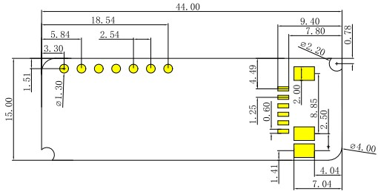

Front

Back

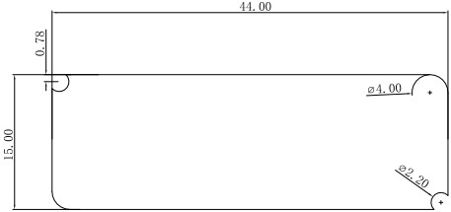

Front

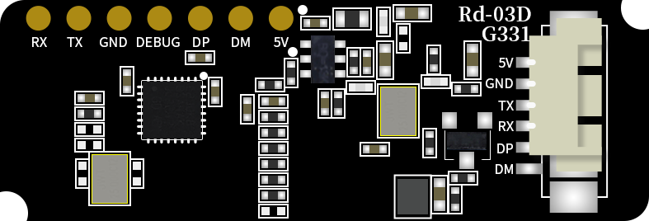

Back

**Figure 4 Size diagram**

# Pin definition

The Rd-03D_V2 module has a total of 4 pins, as shown in the pin diagram. The pin function definition table is the interface definition.

**Figure 5 Schematic diagram of the tube feet**



Front



Back

|  |  |  |
| --- | --- | --- |
| **No** | **Pin name** | **Function description** |
| 1 | 5V   |  |  |  | | --- | --- | --- | |  |  |  | |  |  |  | |  |  |  | |  |  |  | |  |  |  | |  |  |  | | Input power |
| 2 | GND | Connect to Ground |
| 3 | TX | UART_TX |
| 4 | RX | UART_RX |

Table 5 Definition table of tube pin function

# Schematic diagram

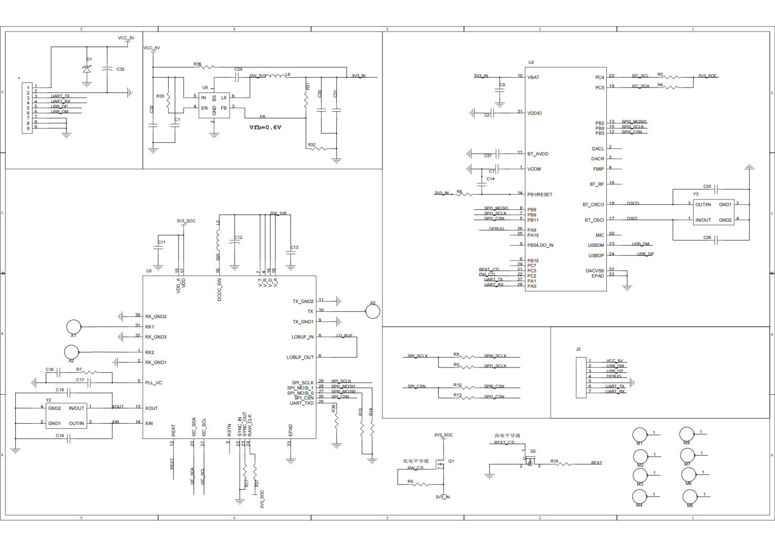

Figure 6 Schematic diagram

# Design guidance

## C:\Users\DPF\Desktop\GZWJ\规格书所需原理图\UART.pngUARTApplication of guidance circuit

Figure 7 Application guidance circuit

# Precautions for radar installation

* In the installation position on the motherboard, the following ways are recommended:
* Try to ensure that the radar antenna is facing the area to be detected, and the antenna is open without shielding.
* To ensure that the installation position of the radar is firm and stable, the shaking of the radar itself will affect the detection effect.
* Make sure that there is no movement or vibration on the back of the radar. Due to the penetration of radar waves, the antenna signal back flap may detect moving objects on the back of the radar. Metal shield or metal backplane can be used to shield the radar back flap and weaken the impact of the radar back object.
* Due to the difference of target shape, state, RCS, the target distance accuracy can also fluctuate slightly.
* When there are multiple 24GHz band radars, please do not beam directly at them and try to install them far away from each other to avoid possible mutual interference.
* In order to meet the performance of on-board antenna, metal parts are prohibited around the antenna, away from high-frequency devices.
* The power input voltage range is 5V, and the power ripple supply should be controlled within 100 mV. Users should consider the corresponding EMC design such as ESD and lightning surge.

## Installation environment requirements

The product needs to be installed in the suitable environment, if used in the following environment, the test effect will be affected:

* There are non-human objects with continuous movement in the induction area, such as animals, curtains that keep swinging, and large green plants facing the air outlet.
* There is a large area of strong reflector in the induction area, which will cause interference to the radar antenna.
* When installing the hanging wall, it is necessary to consider the external interference factors such as the air conditioning and electric fan on the top of the room.

## Installation method and sensing range

* Radar hanging wall mounting method

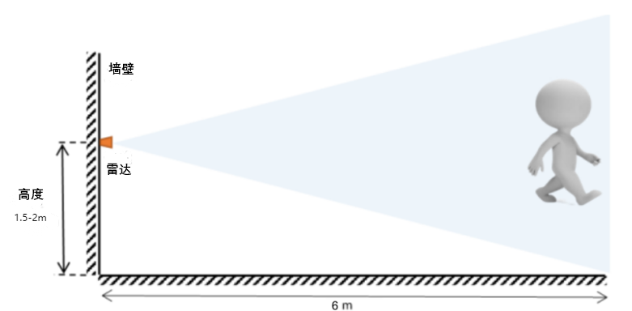Figure 8 Schematic diagram of the hanging wall installation

Figure 9 Schematic diagram of the hanging wall detection range

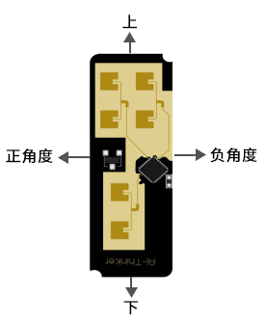

（a）

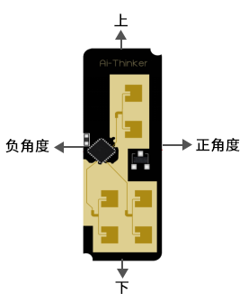

（b）

Note: The recommended radar installation orientation is FIG. 10 (a) or (b), the positive and negative direction is azimuth, the upper and lower direction is elevation, and the normal direction of radar antenna is 0°

* The azimuth Angle of the detection range is ±60, the pitch Angle is ±30, and the maximum detection distance in the normal direction is 8m

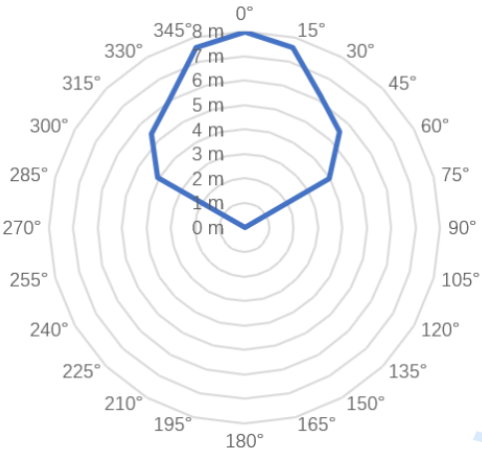Figure 10 Schematic diagram of the tracking range of the hanging wall installation

## Power supply

* Recommended 5V voltage, peak current above 200mA.
* It is recommended to use LDO power supply; if DC-DC is used, the ripple control should be less than 100mV.
* The DC-DC power supply circuit suggests to reserve the position of the dynamic response capacitor, which can optimize the output ripple when the load change is large.
* The 5V power interface is recommended to add ESD components.

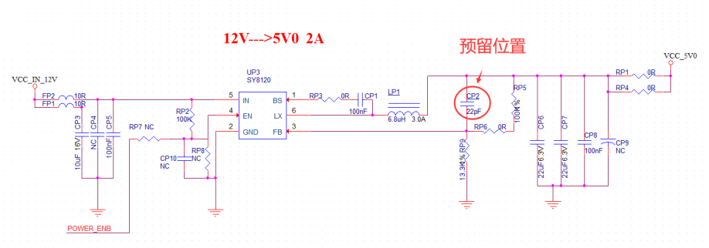Figure 11 DC-DC voltage reduction circuit diagram

## GPIO

* Outside the module, there are some IO ports, such as using the recommended resistance of 10 to 100 ohms in series on the IO port. This suppresses overshoot and smoother both levels, helpful for both EMI and ESD.
* The pull-up and pull-down of the special IO port should refer to the usage instructions in the specification book, which will affect the startup configuration of the module.
* The IO port of the module is 3.3V. If the main control does not match the IO port level of the module, the level conversion circuit needs to be added.
* If the IO port is directly connected to the peripheral interface or terminals, it is recommended to reserve ESD devices at the IO port line near the terminal.

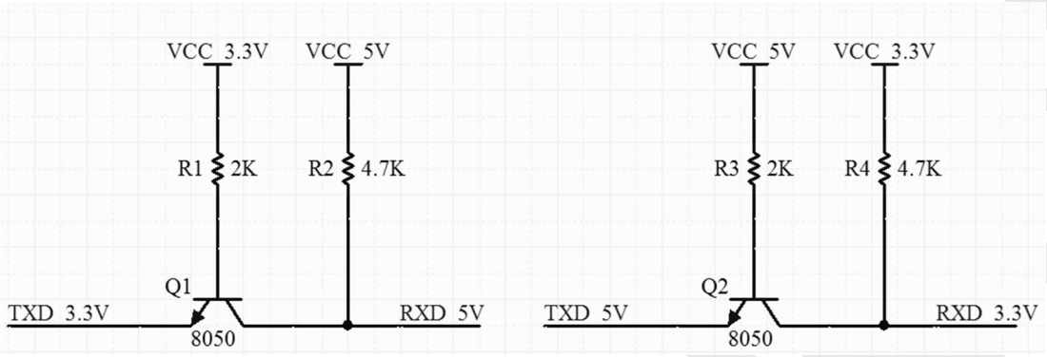Figure 12 Level conversion circuit

# Storage condition

Products sealed in moisture bags should be stored in a non-condensing atmosphere with <40℃/90%RH.The moisture sensitivity level MSL of the module is 3.

After unpacking the vacuum bag, it must be used up within 168 hours under 25±5℃/60%RH, otherwise it needs to be baked before being put online again.

# Reflow welding curve

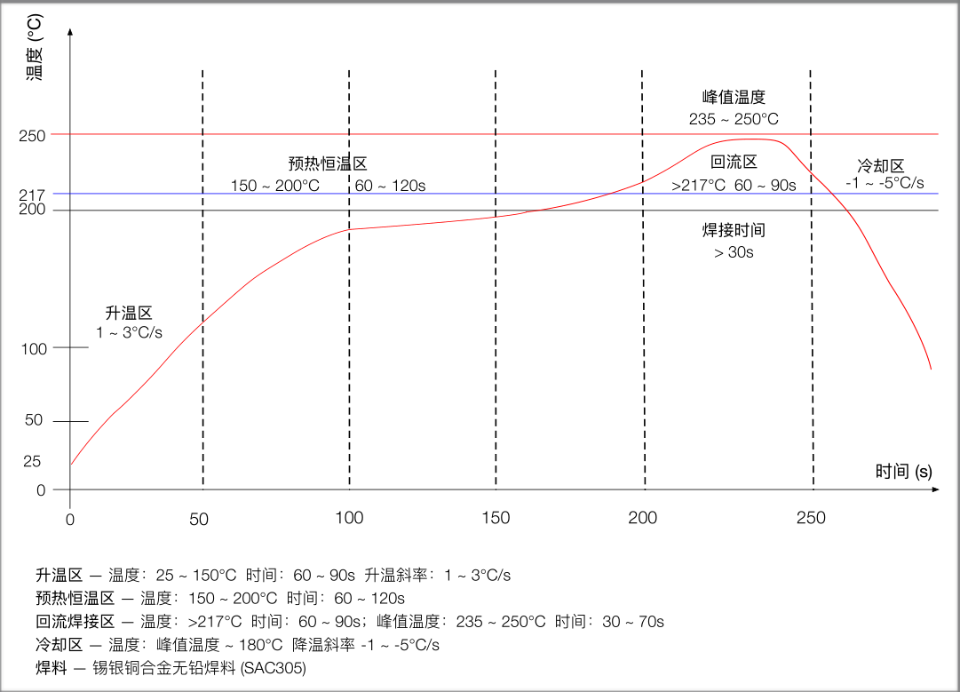

Figure 13 Reflow weld curve diagram

# Product packaging information

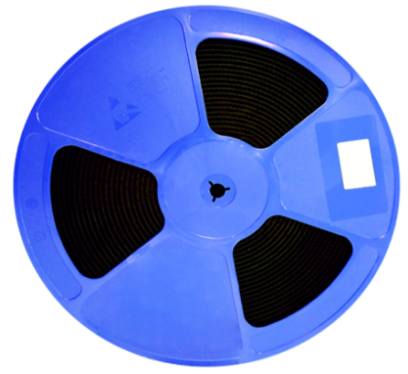Rd-03D_V2 module is packaged with 500 pcs / disk. As shown in the figure below:

Figure 14 Packing tape diagram

# Contact us

[Ai-Thinker official website](https://www.ai-thinker.com) [Office forum](http://bbs.ai-thinker.com) [Develop DOCS](https://docs.ai-thinker.com) [LinkedIn](https://www.linkedin.com/company/ai-thinker) [Tmall shop](https://aithinker.tmall.com) [Taobao shop](https://anxinke.taobao.com/) [Alibaba shop](https://ai-thinker.en.alibaba.com)

[Technical support email：support@aithinker.com](mailto:support@aithinker.com)

[Domestic business cooperation：sales@aithinker.com](mailto:sales@aithinker.com)

[Overseas business cooperation：overseas@aithinker.com](mailto:overseas@aithinker.com)

Company Address：Room 403-405,408-410, Block C, Huafeng Smart Innovation Port, Gushu 2nd Road, Xixiang, Baoan District, Shenzhen.

Tel：+86-0755-29162996





WeChat mini

WeChat offical

# **Disclaimer and copyright notice**

The information in this article, including the URL address for reference, is subject to changewithout notice. The document is provided "as is" without any guarantee responsibility, including any guaranteefor merchantability, suitability for a specific purpose, or non-infringement, and any guaranteementioned elsewhere in any proposal, specification or sample. This document does not bear any responsibility, including the responsibility for infringement of any patent rights arisingfrom the use of the information in this document. This document does not grant any licenseforthe use of intellectual property rights in estoppel or other ways, whether express or implied. The test data obtained in the article are all obtained from Ai-Thinker's laboratory tests, andtheactual results may vary slightly. All brand names, trademarks and registered trademarks mentioned in this article are the property of their respective owners, and it is hereby declared. The final interpretation right belongs to Shenzhen Ai-Thinker Technology Co., Ltd.

# Notice

Due to product version upgrades or other reasons, the contents of this manual may be changed. Shenzhen Ai-Thinker Technology Co., Ltd. reserves the right to modify the contents of this

manual without any notice or prompt. This manual is only used as a guide. Shenzhen Ai-Thinker Technology Co., Ltd. makes everyeffort to provide accurate information in this manual. However, Shenzhen Ai-Thinker

Technology Co., Ltd. does not guarantee that the contents of the manual are completelyfreeoferrors. All statements and information in this manual. And the suggestion does not constituteany express or implied guarantee.

# Important statement

Ai-Thinker may provide technical and reliability data "as is" (including data sheets), design resources (including design for reference purposes), application or other design recommendations, network tools, security information and other resources (the "these resources") and without warranty without express or implied warranty, including without limitation, adaptability for a particular purpose or infringement of intellectual property rights of any third party. And specifically declares that it is not liable for any inevitable or incidental losses arising from the application or the use of any company products and circuits.

Ai-Thinker reserves the right to the information released in this document (including but not limited to the indicators and product description) and any changes to the Company without notice to automatically replace and replace all the information provided in the previous version of the same document number document.

These resources are available to skilled developers who design Ai-Thinker products. You will assume all responsibilities for the following: (1) select the appropriate optional products for your application; (2) design, verify, and run your application and products during the full life cycle; and (3) ensure that your application meets all corresponding standards, norms and laws, and any other functional security, information security, regulatory or other requirements.

Ai-Thinker authorizes you to use these resources only for the application of the Essence products described in this resource. Without the permission of Ai-Thinker, no unit or individual shall copy or copy part or all of these resources without authorization, and shall not spread them in any form. You are not entitled to use any other Principal or any third party intellectual property. You shall fully indemnify you for any claims, damages, costs, losses and debts incurred by the result of the use of these resources.

The products available by Ai-Thinker are subject to the terms of sales or other applicable terms attached to the products. Ai-Thinker may provide these resources does not extend or otherwise change the applicable warranty or warranty disclaimer for the product release.