PB-02 Specifications
Version V1.0
Copyright ©2020

Disclaimer and copyright notice
The information in this article, including the URL address for reference, is subject to change without notice.The Documentation is provided "as is" without any warranty, including any warranties of merchantability, fitness for a particular purpose, or non-infringement, and any warranties mentioned in the proposal, specification or sample. This document is not responsible for any infringement of any patent rights arising out of the use of the information in this document. No license, express or implied, by estoppel or otherwise, is hereby granted.

The test data obtained in this paper are all obtained by Ai-Thinker laboratory , and the actual results may be slightly different.The Wi-Fi alliance membership mark is owned by the WiFi alliance.

All trade mark names, trademarks and registered trademarks mentioned herein are the property of their respective owners and are hereby declared.
The final interpretation right is owned by Shenzhen Ai-Thinker Technology Co., Ltd.

Note
The contents of this manual may be changed due to the version upgrade of the product or other reasons. Shenzhen Ai-Thinker Technology Co., Ltd. reserves the right to modify the contents of this manual without any notice. This manual is only used as a guide, and Shenzhen Ai-Thinker Technology Co., Ltd. makes every effort to provide accurate information in this manual, but Shenzhen Ai-Thinker Technology Co., Ltd. does not ensure that the contents of the manual are completely true.All statements and information in this manual,and the recommendations do not constitute for any warranty, express or implied.

Document development / revision / revocation resume
Version | Date | Development/revision | Development | Approval
V1.0 | 2020.05.29 | Initial development | Xie Yiji

Contents

一. Product Overview 5
二. Electrical parameters 7
三. Appearance dimensions 9
四. Definition of pins 10
五. Schematic diagrams 12
六. Design guidance 12
七. Reflow soldering 16
八. Packaging information 17
九. Contact us 17

- Product Overview
PB-02 is a BLE 5.0 low-power Bluetooth module based on PHY6212 chip; supports SIGMesh.. PHY6212 is equipped with ARM® Cortex™-M0 32-bit processor, 138KB SRAM, ultra-low power consumption,high performance and wireless multi-mode characteristics,, supports BLE functions of security, applications and wireless updates.
PB-02 module has the function of Bluetooth mesh networking; the communication between devices through peer-to-peer network, using Bluetooth broadcast for communication, can ensure timely response in the case of multiple devices. It is mainly used in intelligent lamp control,wearable smart device, retail payment and other Internet of things fields; it can meet the requirements of low power consumption, low delay, low cost wireless data communication.

Characteristics
- 1.1 mm spacing SMD-20 package
- 6 channels PWM output
- The antenna adopts PCB onboard antenna; at the same time, half hole pad and antenna hole are reserved. The half-hole pad can guide the antenna to the motherboard, and the antenna hole can be directly welded to the spring antenna.
- Brightness (duty cycle) adjustment range 5%-100%
- Factory default cool and warm color 50%
- PWM output frequency 1KHz
- Features with Nightlight
- Switching Color Temperature with Wall Switching

Main parameters
Table 1 main parameter descriptions
Model | PB-02
Dimensions | 12.2*18.6*2.3(±0.2) MM
Package | SMD-20
Wireless Standards | Bluetooth 5.0
Frequency range | 2400~2483.5 MHz
Maximum transmit power | Maximum dBm 10
Receiving sensitivity | -93±2 dBm
Interface | GPIO/PWM/SPI/ADC
Operating temperature | -40℃ ~ 85 ℃
Storage environment | -40℃~125℃,<90%
Power supply range | Supply voltage 2.7 V ~3.6 V, supply current ≥50 mA
Power consumption | Deep sleep mode :0.7 uA (IO wake-up)
 | Dormancy mode :2 uA (RTC wake-up)
 | RX mode :7 mA
 | TX (10dBm):25mA

- Electrical parameters

Electrical characteristics
PB-02 module is electrostatic sensitive equipment, when handling need to take special precautions
Absolute maximum rating
Any more than the following absolute maximum values can cause module damage
Name | Minimum value | Typical values | Maximum value | Units
Supply voltage | 2.7 | 3.3 | 3.6 | V
I/O supply voltage (VCCIO) | -0.3 | - | 3.6 | V
Operating temperature | -40 | - | +85 | ℃
Storage temperature | -40 | - | +125 | ℃

Power consumption
Name | Typical values | Units
Emission power consumption (10 dBm) | 25 | mA
Receiving Power | 7 | mA
Light Sleep | 2 | uA
Deep Sleep | 0.7 | uA

RF parameters
Transmission power
Name | Minimum value | Typical values | Maximum value | Units
Average power | - | 8.5 | 10 | dBm
Receiving sensitivity
Name | Minimum value | Typical values | Maximum value | Units
Receiving sensitivity | -95 | -93 | - | dBm

- Appearance dimensions
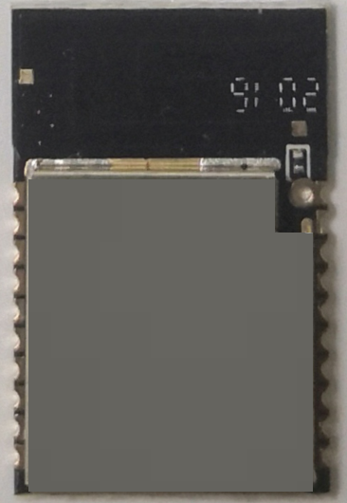
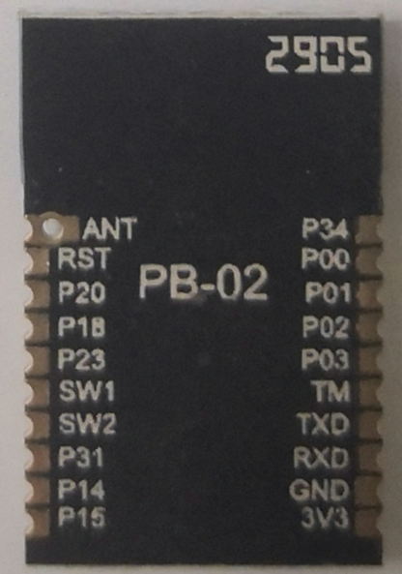
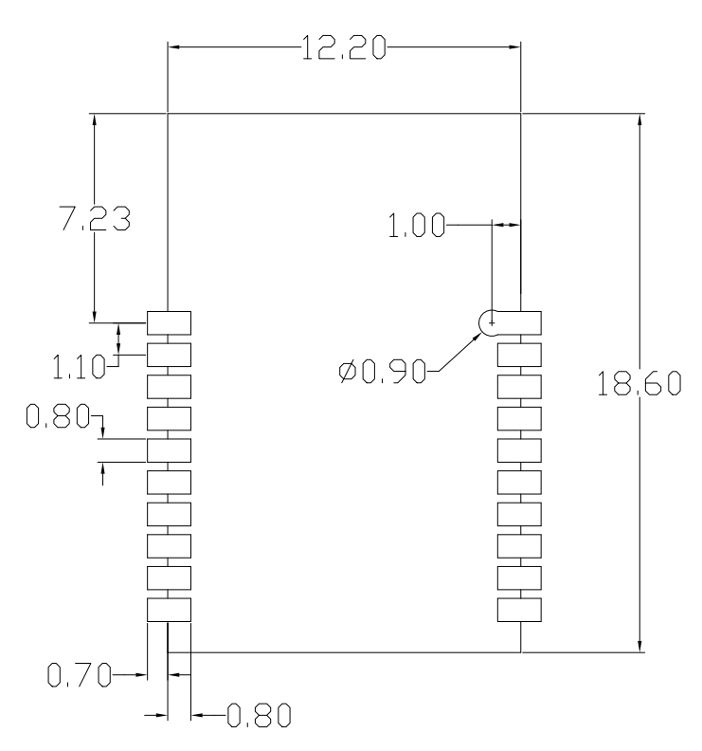

四. Definition of pins
PB-02 Foot Schemes

The PB-02 module has a total of 20 interfaces. As shown in the pin diagram, the pin function definition table is the interface definition.

Foot function definition table
No. | Name | Functional Description
1 | P34 | GPIO34, all features are configurable  *Note: Interrupt and ADC functions are not supported
2 | P00 | GPIO00, all functions are configurable/ JTAG_TDO  *Note: ADC functionality not supported
3 | P01 | GPIO01, all functions are configurable/ JTAG_TDI  *Note: ADC functionality not supported
4 | P02 | GPIO02, all functions are configurable/ JTAG_TMS  *Note: ADC functionality not supported
5 | P03 | GPIO03, all functions are configurable/ JTAG_TCK  *Note: ADC functionality not supported
6 | TM | Flash mode selection, this pin pull-up to high level , boot start into flash mode
7 | TXD | Serial URAT_TXD
8 | RXD | Serial URAT_RXD
9 | GND | Ground
10 | 3V3 | Power supply, typical value 3.3 V
11 | P15 | GPIO15, all features configurable/ AIO <4>
12 | P14 | GPIO14, all features are configurable/ AIO <3>
13 | P31 | GPIO31, all features are configurable  *Note: Interrupt and ADC functions are not supported
14 | SW2 | GPIO25, all functions configurable/test mode start configuration [1], this pin pull-up to high level , boot start into test mode
15 | SW1 | GPIO24, all features configurable/test mode start configuration [0]
16 | P23 | GPIO23, all features are configurable  *Note: Interrupt and ADC functions are not supported
17 | P18 | GPIO18, all functions are configurable/ AIO <7>/ PGA differential positive input  *Note: Interrupt functionality not supported
18 | P20 | GPIO20, all functions are configurable/ AIO <9>/ microphone bias output  *Note: Interrupt functionality not supported
19 | RST | Reset pin
20 | ANT | Antenna interface

五. Schematic diagrams
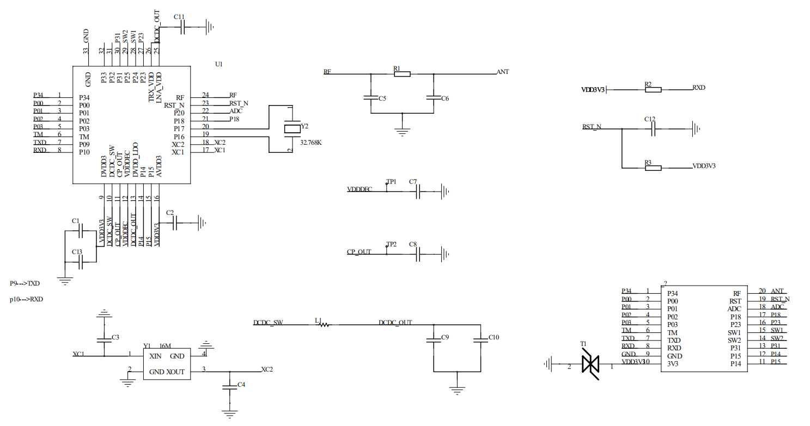

六. Design guidance
- Application circuit
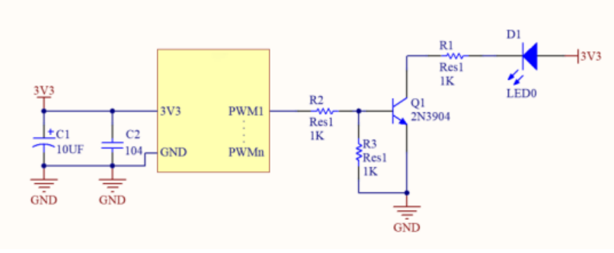

2. recommended module package design dimensions
Note: This is the PB-02 module package diagram, It is recommended to design the PCB board according to this diagram, so that the module can work normally on the PCB board; and when designing the pads, please pay attention to the design of the pads on the PCB. The pad is retracted and offset, and the PCB pad is expanded from the module pad do not affect the use of the module.

3. antenna layout requirements
(1)、For the installation position on the motherboard, the following two methods are recommended:
- Solution 1: Put the module on the edge of the motherboard, and the antenna area extends out of the edge of the motherboard.
- Solution 2: Put the module on the edge of the motherboard, and hollow out an area at the antenna position on the edge of the motherboard.
- In order to meet the performance of the onboard antenna, it is forbidden to place metal parts around the antenna, away from high-frequency components.
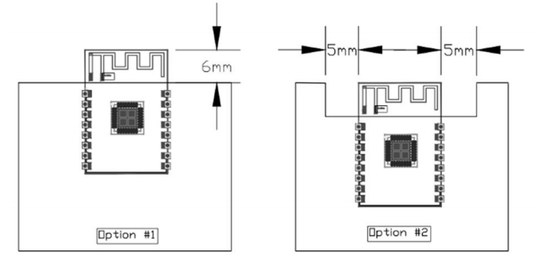

4. power supply
(1)、 Recommend 3.3V voltage, peak current above 50mA
(2)、 It is recommended to use LDO for power supply; if DC-DC is used, the ripple is recommended to be controlled within 30mV.
(3)、It is recommended to reserve the position of the dynamic response capacitor for the DC-DC power supply circuit, which can optimize the output ripple when the load changes greatly.
(4),It is recommended to add ESD devices to the 3.3V power interface
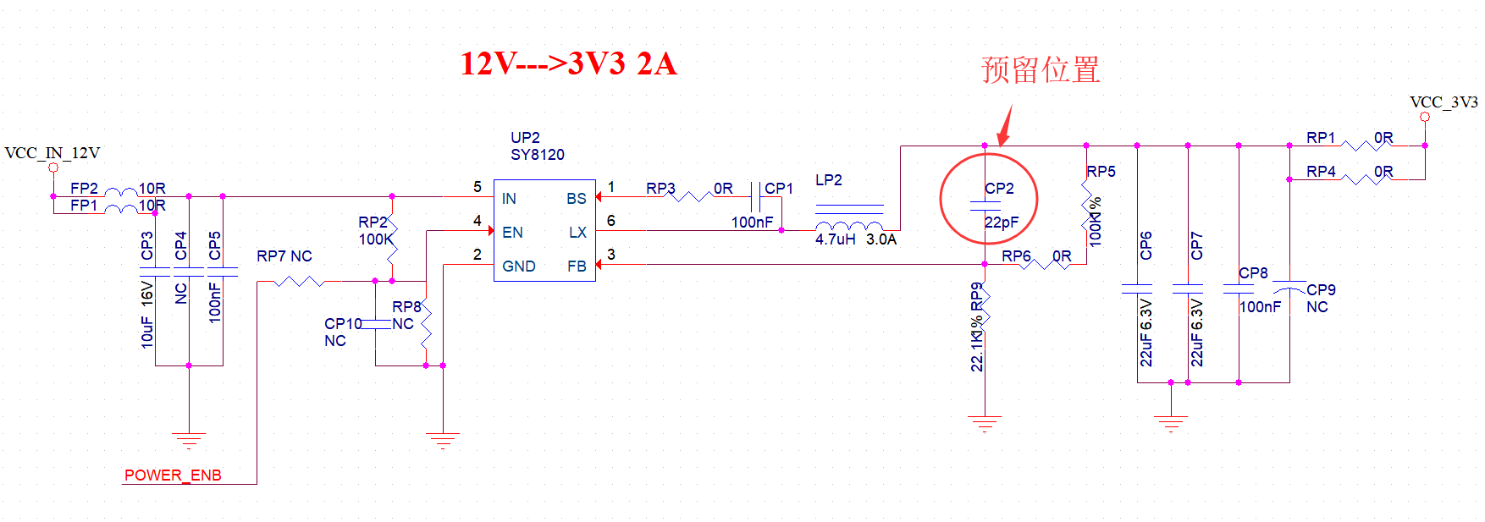

- Design description of PWM dimming scheme
For lamps that require dimming function, only require to connect the PWM pin of the corresponding color to the control end of the subsequent drive circuit; PWM independent output is a digital signal with 100 levels of adjustable duty cycle, and the subsequent circuit can be voltage drive type or a current drive type.
Diagram of connection

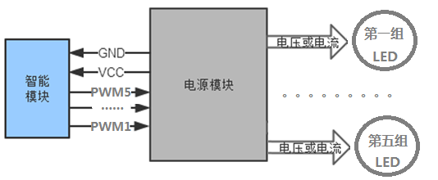
6.LED Drive Reference Design
The PB-02 module application only requires 3.3V power supply and a simple drive circuit to realize smart light control. Take the MOS tube driving a positive white light as an example. The design refers to the following figure; CW_I is the PWM output pin of the positive white light of the module , Q1 is a MOS tube, WW is an LED lamp bead, and the design method of the other 4-way lamp driving circuit is the same as this way.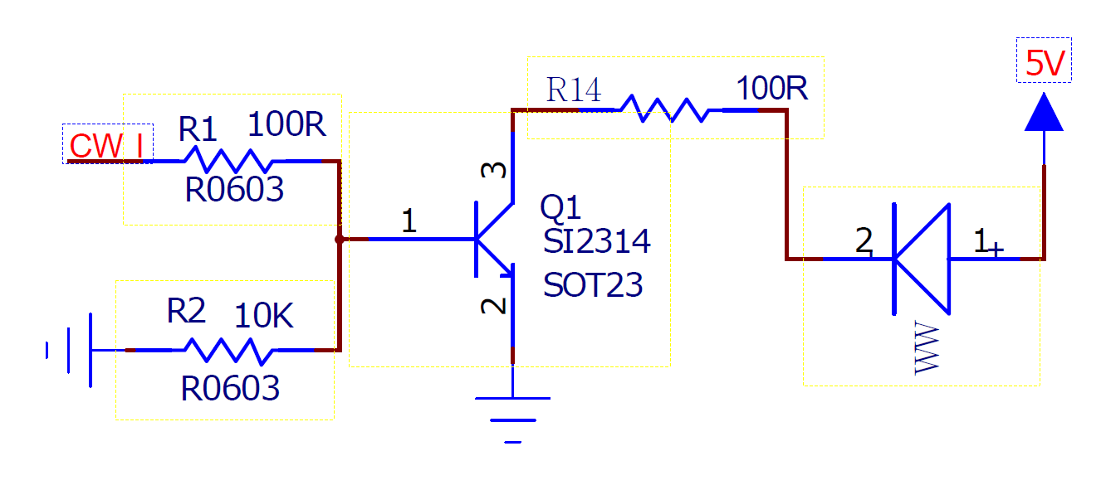

七. Reflow soldering
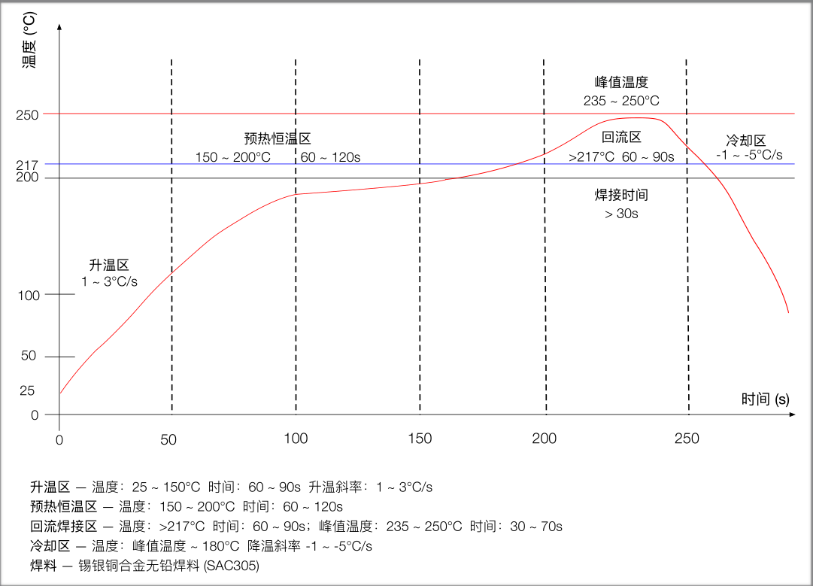

八.Packaging information
as shown below, the PB-02 packing is tape packing.
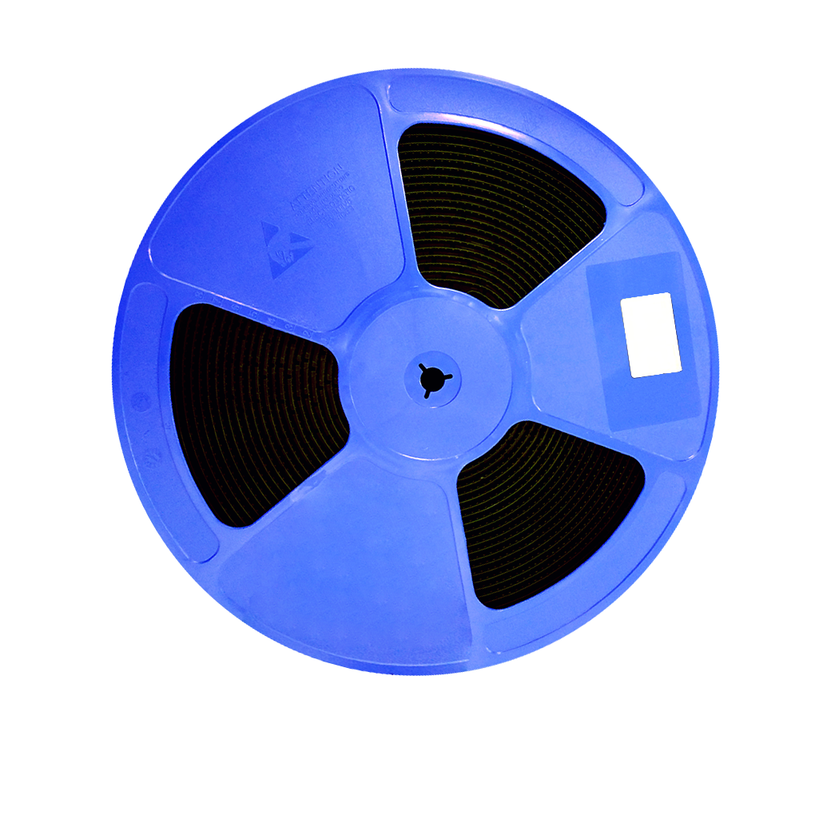

九. Contact us
Official website: https://www.ai-thinker.com
Development DOCS ：http s ：//d ocs.ai-thinker.com
Official Forum: http://bbs.ai-thinker.com
Sample purchase: https://anxinke.taobao.com
Business cooperation: sales@aithinker.com
Technical support: support@aithinker.com
Company Address: Building C, Huafeng Intelligent Innovation Port, Xixiang, Baoan District, Shenzhen
Tel :0755-29162996

